Operating System Lab

Arnav Samal

122CS0107

Assignment – 1

C Programs

Q1. WAP to Add 2 Numbers

Code:

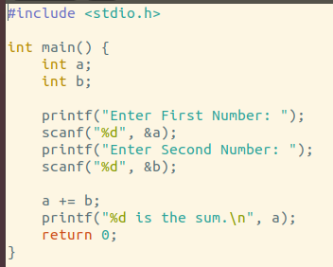

Output:

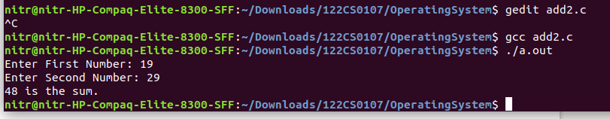

Q2. WAP to check if a number is prime or not

Code:

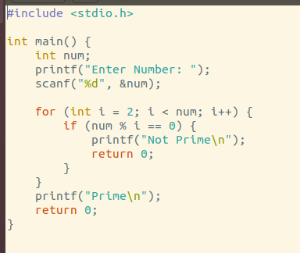

Output:

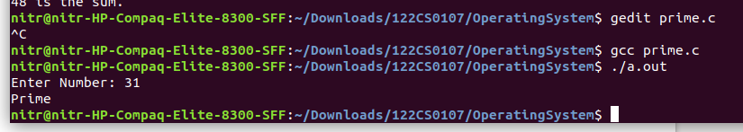

Commands (any 5)

1. date

**date** command is used to display the system date and time. date command is also used to set date and time of the system. By default the date command displays the date in the time zone on which unix/linux operating system is configured.You must be the super-user (root) to change the date and time.



1. who

The who command is a simple and effective way to display information about currently logged-in users. By typing who in the terminal, you will receive a list of usernames, terminal IDs, login times, and originating IP addresses if applicable.



1. lsb_release -a

The **lsb_release** command prints certain LSB (Linux Standard Base) and Distribution information.

If no options are given, the *-v* option is assumed.

-a displays all of the above information.

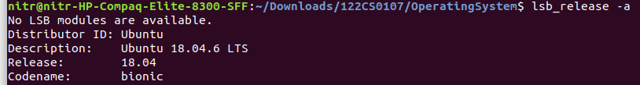

1. time

**time** command in Linux is used to execute a command and prints a summary of real-time, user CPU time and system CPU time spent by executing a command when it terminates. ‘*real*‘ time is the time elapsed wall clock time taken by a command to get executed, while ‘*user*‘ and ‘*sys*‘ time are the number of CPU seconds that command uses in user and kernel mode respectively.

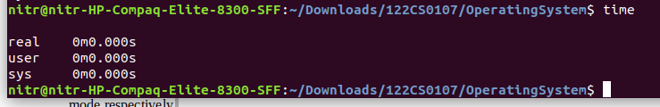

1. touch

The **touch** command is a standard command used in the UNIX/Linux operating system which is used to create, change and modify the timestamps of a file.

